CSS-HTML Exam —-4bhrs

1. Design a form with input fields for name, email, and message.

Ans:

HTML File:

<!DOCTYPE html>

<html lang="en">

  <head>

    <meta charset="UTF-8" />

    <meta name="viewport" content="width=device-width, initial-scale=1.0" />

    <title>form</title>

    <link rel="stylesheet" href="form.css" />

  </head>

  <body>

    <div class="form-container">

      <form class="form-fields">

        <div class="field">

          <label for="name">Username:</label>

          <input

            type="text"

            placeholder="Enter the username here!"

            id="name"

            name="name"

          />

        </div>

        <div class="field">

          <label for="email">Email:</label>

          <input

            type="email"

            placeholder="Enter the Email!"

            id="email"

            name="email"

          />

        </div>

        <div class="field-message">

          <label for="message">message</label>

          <textarea id="message" name="message"></textarea>

        </div>

        <div class="button">

          <input type="submit" value="submit" />

        </div>

      </form>

    </div>

  </body>

</html>

CSS File:

* {

  margin: 0px;

  padding: 0px;

  box-sizing: border-box;

}

.form-container {

  display: flex;

  justify-content: center;

  align-items: center;

  height: 100vh;

}

.form-container .form-fields {

  border: 2px solid #80d4ff;

  width: 50%;

  padding: 30px;

  background-color: #ffb3d1;

  border-radius: 10px;

}

.form-container .form-fields .field input {

  width: 100%;

  padding: 5px;

  border: 2px solid rgb(201, 95, 111);

  border-radius: 5px;

  margin-bottom: 8px;

  margin-top: 5px;

}

.form-container .form-fields .button input {

  width: 100%;

  padding: 5px;

  border: none;

  border-radius: 5px;

  margin-bottom: 8px;

  margin-top: 5px;

  background-image: linear-gradient(270deg, #80bfff, #ff884d, lightskyblue);

  color: #ffff;

  font-size: 20px;

  font-family: sans-serif;

}

.form-container .form-fields .field-message textarea {

  width: 100%;

  padding: 5px;

  border: 2px solid rgb(201, 95, 111);

  border-radius: 5px;

  margin-bottom: 8px;

  margin-top: 5px;

}

Output:

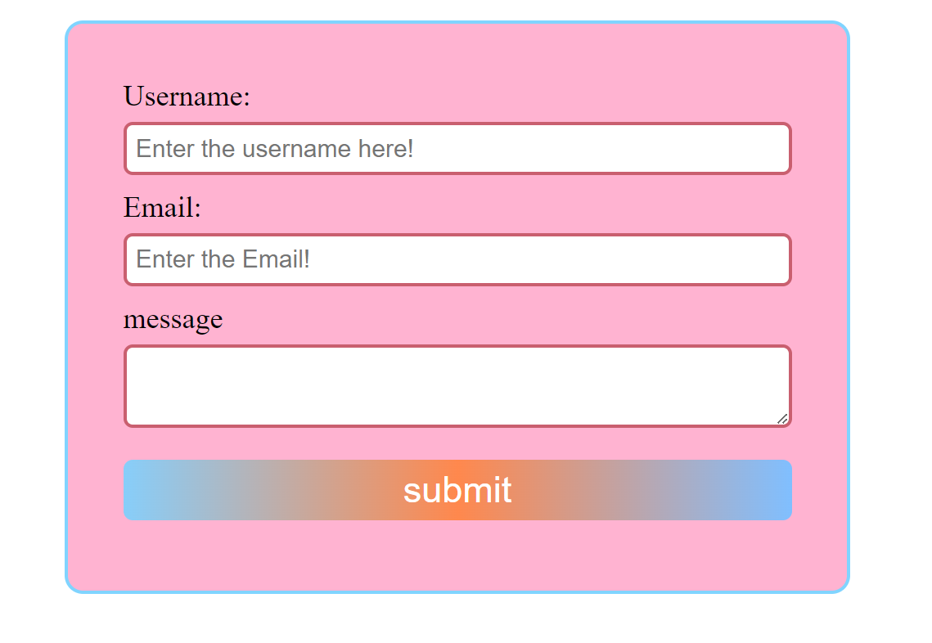

1. Create a three-column layout using CSS grid or flexbox.

Ans:

HTML File:

<!DOCTYPE html>

<html lang="en">

  <head>

    <meta charset="UTF-8" />

    <meta name="viewport" content="width=device-width, initial-scale=1.0" />

    <title>Three column</title>

    <link rel="stylesheet" href="threecolumn.css" />

  </head>

  <body>

    <div class="three-column">

      <div class="table-column">

        <table>

          <tr>

            <th>name</th>

            <th>location</th>

          </tr>

          <tr>

            <td>venkatesh</td>

            <td>vizag</td>

          </tr>

          <tr>

            <td>Ram charan</td>

            <td>hyd</td>

          </tr>

        </table>

      </div>

      <div class="form-column">

        <form>

          <div class="name-field">

            <label for="name">Name:</label>

            <input type="text" id="name" name="name" />

          </div>

          <input class="button" type="submit" value="submit" />

        </form>

      </div>

      <div class="details-column">

        <h2>Maicherla venkatesh</h2>

        <p>works at greemus</p>

      </div>

    </div>

  </body>

</html>

CSS File:

* {

  margin: 0px;

  padding: 0px;

  box-sizing: border-box;

}

.three-column {

  display: grid;

  grid-template-columns: repeat(3, 1fr);

  grid-gap: 20px;

  margin: auto;

  padding: 20px;

}

.three-column .table-column table,

th,

td {

  border: 2px solid rgb(114, 12, 21);

  border-collapse: collapse;

  padding: 10px;

  background-color: #ccffdd;

  width: 100%;

}

.three-column .form-column {

  border: 2px solid lightpink;

  padding: 20px;

  width: 100%;

}

.three-column .form-column .name-field input {

  width: 100%;

  border: 2px solid lightslategray;

  border-radius: 4px;

}

.three-column .form-column .button {

  width: 100%;

  border: none;

  border-radius: 4px;

  margin-top: 10px;

  background-color: #4da6ff;

  color: #ffff;

}

.three-column .details-column {

  border: 2px solid lightgreen;

  padding: 20px;

  text-align: center;

  font-weight: 300;

}

Output:

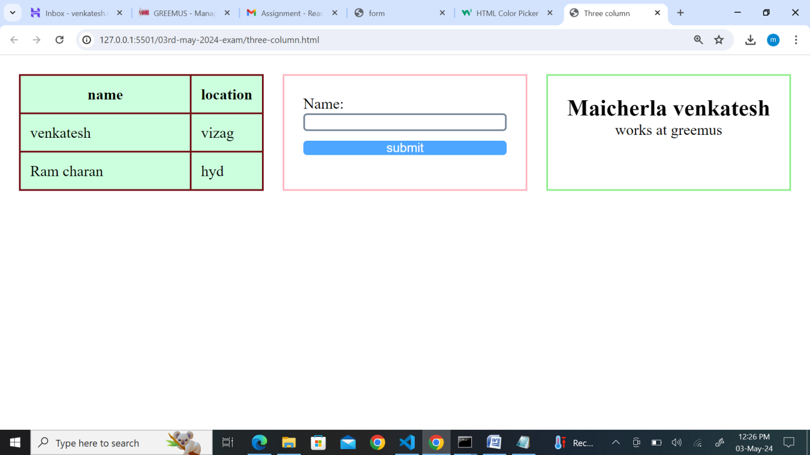

1. Make a responsive website that adjusts its layout for different screen sizes.

Ans:

HTML File:

1. Style a button to change its appearance when hovered over.

Ans:

HTML File:

<!DOCTYPE html>

<html lang="en">

  <head>

    <meta charset="UTF-8" />

    <meta name="viewport" content="width=device-width, initial-scale=1.0" />

    <title>hover</title>

    <link rel="stylesheet" href="hover.css" />

  </head>

  <body>

    <div class="hover-example">

      <form class="form-fields">

        <div class="name-field">

          <label for="name">name</label>

          <input

            type="text"

            placeholder="Enter the name here!"

            id="name"

            name="name"

          />

        </div>

        <button>Submit</button>

      </form>

    </div>

  </body>

</html>

CSS File:

* {

  margin: 0px;

  padding: 0px;

  box-sizing: border-box;

}

.hover-example {

  display: flex;

  justify-content: center;

  align-items: center;

  height: 100vh;

}

.hover-example .form-fields {

  border: 2px solid lightpink;

  border-radius: 4px;

  padding: 20px;

  width: 50%;

}

.hover-example .form-fields .name-field input {

  width: 100%;

  border: none;

  padding: 5px;

  margin: 10px 0px;

}

.hover-example .form-fields button {

  width: 100%;

  border: none;

  text-align: center;

  font-size: 20px;

  background-color: rgb(60, 133, 223);

  color: #fff;

  border-radius: 10px;

}

.hover-example .form-fields .name-field input:hover {

  border: 3px solid rgb(186, 3, 30);

  border-radius: 6px;

}

.hover-example .form-fields button:hover {

  background-color: lightcoral;

  color: black;

}

Output:

Without Hover:

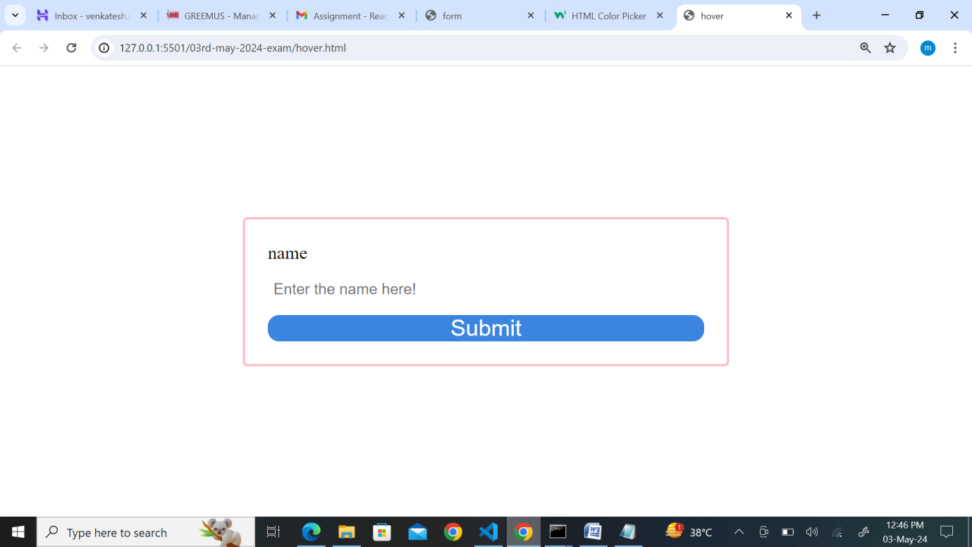

With Hover:

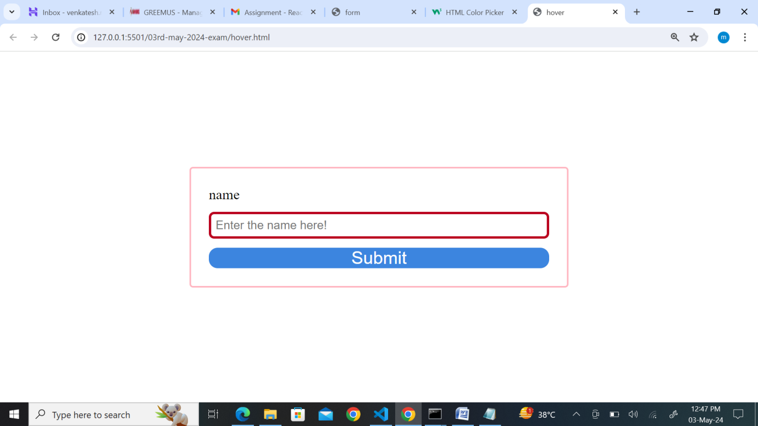

1. Create a dropdown menu using HTML and CSS.

Ans:

HTML File:

<!DOCTYPE html>

<html lang="en">

  <head>

    <meta charset="UTF-8" />

    <meta name="viewport" content="width=device-width, initial-scale=1.0" />

    <title>dropdown-menu</title>

    <link rel="stylesheet" href="dropdown.css" />

  </head>

  <body>

    <div class="dropdown-list">

      <select>

        <option>select names from the list</option>

        <option>Rohit</option>

        <option>jaiswal</option>

        <option>kohli</option>

        <option>surya</option>

        <option>pant</option>

        <option>jadeja</option>

        <option>hardik</option>

        <option>bumrah</option>

        <option>siraj</option>

        <option>kuldeep</option>

        <option>arshadeep</option>

      </select>

    </div>

  </body>

</html>

CSS File:

* {

  margin: 0px;

  padding: 0px;

  box-sizing: border-box;

}

.dropdown-list {

  display: flex;

  justify-content: center;

  align-items: center;

  height: 100vh;

}

.dropdown-list select {

  border: 3px solid lightseagreen;

  padding: 10px;

  width: 50%;

  border-radius: 20px;

  -webkit-appearance: none;

}

.dropdown-list select option {

  font-size: 15px;

  font-family: "Lucida Sans", "Lucida Sans Regular", "Lucida Grande",

    "Lucida Sans Unicode", Geneva, Verdana, sans-serif;

}

Output:

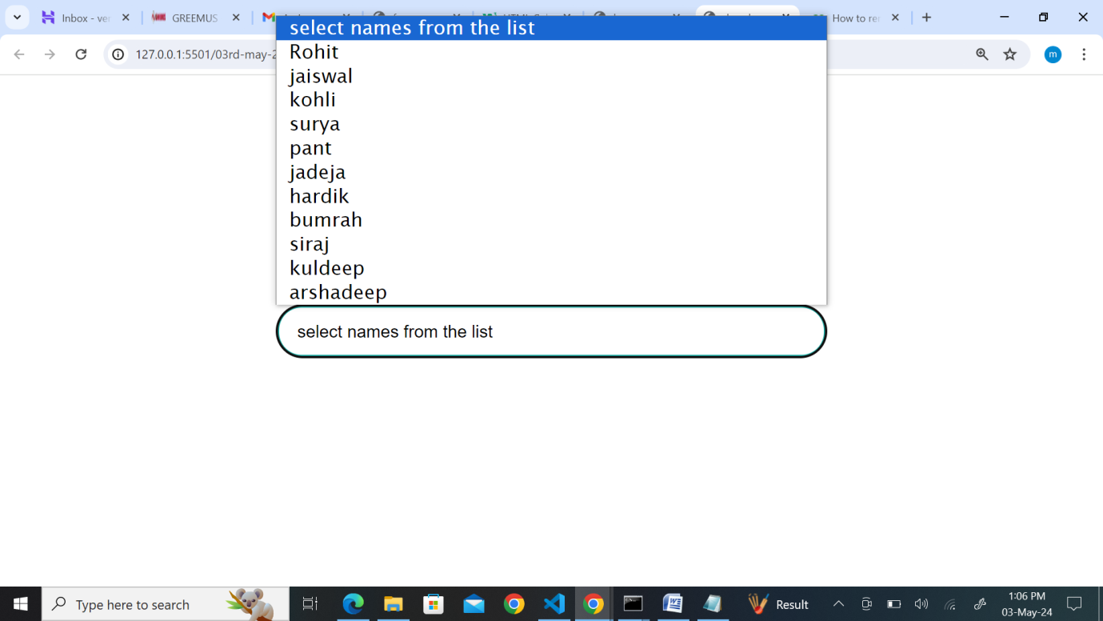

1. Build a simple slideshow using HTML, CSS, and JavaScript.

Ans:

1. Design a pricing table with multiple plans using HTML and CSS.

Ans:

HTML File:

<!DOCTYPE html>

<html lang="en">

  <head>

    <meta charset="UTF-8" />

    <meta name="viewport" content="width=device-width, initial-scale=1.0" />

    <title>table-pricing</title>

    <link rel="stylesheet" href="pricing-table.css" />

  </head>

  <body>

    <div class="prcing-table">

      <div class="plans">

        <h2>yearly plan</h2>

        <div>$1049<span>/yearly</span></div>

        <ul>

          <li>Movies</li>

          <li>Shows</li>

          <li>Events</li>

        </ul>

        <button>Choose a plan</button>

      </div>

      <div class="plans">

        <h2>3-months</h2>

        <div>$149<span>/month</span></div>

        <ul>

          <li>Movies</li>

          <li>Shows</li>

          <li>Events</li>

        </ul>

        <button>Choose a plan</button>

      </div>

      <div class="plans">

        <h2>6-months</h2>

        <div>$640<span>/6months</span></div>

        <ul>

          <li>Movies</li>

          <li>Shows</li>

          <li>Events</li>

        </ul>

        <button>Choose a plan</button>

      </div>

    </div>

  </body>

</html>

CSS File:

* {

  margin: 0px;

  padding: 0px;

  box-sizing: border-box;

}

.prcing-table {

  display: flex;

  justify-content: center;

  align-items: center;

  margin-top: 50px;

}

.plans {

  background-color: #0badd5;

  padding: 20px;

  text-align: center;

  border-radius: 10px;

  box-shadow: 0 0 10px rgba(210, 119, 166, 0.1);

  transition: transform 0.3s;

  margin: 30px;

}

.plans h2 {

  text-align: center;

  font-weight: bold;

  font-family: Cambria, Cochin, Georgia, Times, "Times New Roman", serif;

  font-size: 20px;

  color: #a8034b;

}

.plans ul {

  list-style-type: none;

  padding: 15px;

  margin: 10px;

}

.plans ul li {

  margin: 10px;

  font-family: "Lucida Sans", "Lucida Sans Regular", "Lucida Grande",

    "Lucida Sans Unicode", Geneva, Verdana, sans-serif;

  font-size: 20px;

  color: rgb(222, 241, 12);

}

.plans div {

  font-weight: bold;

  font-size: 20px;

  margin-top: 20px;

}

.plans:hover {

  transform: translateY(-20px);

}

.prcing-table button {

  border: none;

  background-color: rgb(10, 92, 186);

  color: rgb(246, 243, 243);

  padding: 10px;

  border-radius: 10px;

}

Output:

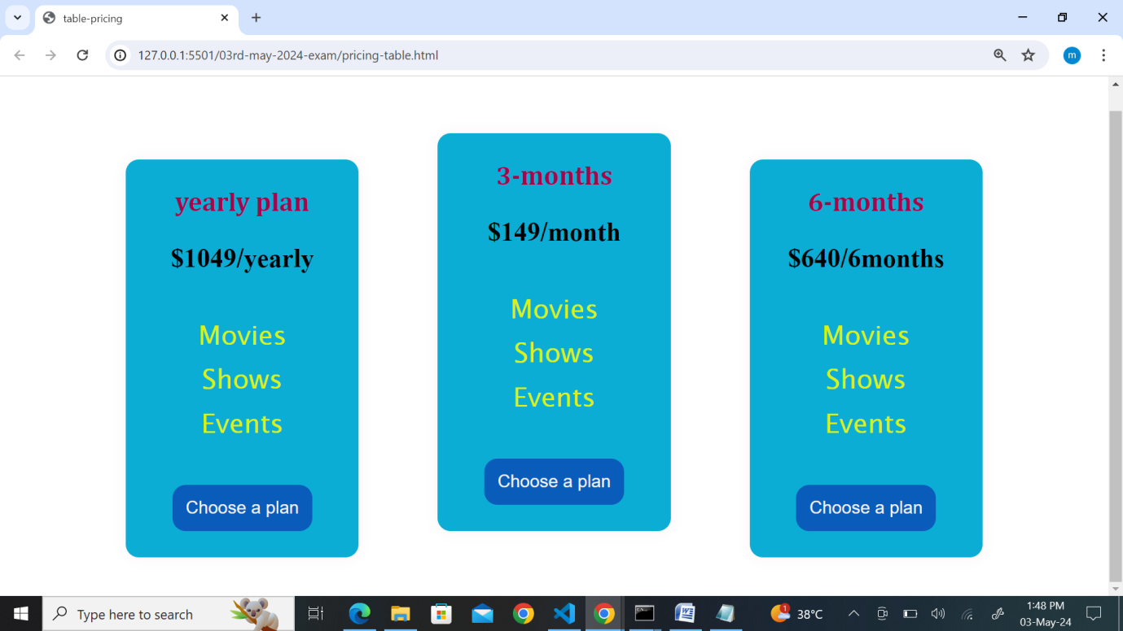

1. Make a sticky navigation bar that stays at the top of the page when scrolling.

Ans:

HTML File:

<!DOCTYPE html>

<html lang="en">

  <head>

    <meta charset="UTF-8" />

    <meta name="viewport" content="width=device-width, initial-scale=1.0" />

    <title>Navbar</title>

    <link rel="stylesheet" href="navbar.css" />

  </head>

  <body>

    <div class="nav-conatiner">

      <section>

        <nav>

          <a href="">Home</a>

          <a href="">About us</a>

          <a href="">Contact us</a>

        </nav>

        <div>

          <h2>maicherla venkatesh</h2>

          <p>

            Lorem ipsum dolor sit amet consectetur adipisicing elit. Suscipit

            eum, incidunt cupiditate consequatur magni dolorum dignissimos quod

            ab, molestias distinctio consequuntur. Tempora necessitatibus

            consequatur at? Accusamus amet modi sapiente illum! Incidunt ab

            autem quo perspiciatis earum numquam modi eos in ipsam possimus

            culpa, repellendus tempore adipisci omnis commodi laboriosam?

            Mollitia minus nemo ullam possimus quisquam voluptates numquam

            doloribus suscipit veritatis? Libero vero eaque quae consequuntur

            totam inventore aut voluptatibus? Pariatur inventore accusamus,

            saepe deleniti, atque sunt laborum expedita asperiores fugiat

            suscipit ratione distinctio, eum et eos nihil enim dolorum repellat!

            Delectus quod placeat corrupti, natus earum hic recusandae rerum

            consequatur cum. Reiciendis, eos. Voluptatibus, placeat vitae

            aliquid molestias culpa quas iure libero esse necessitatibus unde

            voluptatum voluptates, temporibus, numquam facere! Ipsam excepturi,

            odit placeat blanditiis aliquam, illum doloribus molestiae,

            molestias magni corporis nobis dolores rem quia odio! Nisi

            recusandae velit soluta qui nihil quod, amet omnis adipisci

            blanditiis veritatis id. Vero recusandae delectus sunt

            exercitationem unde labore tempore quibusdam, consequuntur

            molestiae, repudiandae earum iure, reiciendis quo. Ad quidem, quasi

            necessitatibus distinctio quo perspiciatis id molestiae, ipsam

            laudantium praesentium, illo molestias? Ipsum rerum eveniet harum ab

            aut hic qui recusandae cumque error totam a consequatur ex eius

            commodi exercitationem inventore, similique saepe ipsam? A rerum

            facere hic! Veniam corrupti repellat delectus! Ratione, recusandae

            rem itaque eveniet cupiditate ipsam voluptate ducimus ipsum iure,

            dicta aut ullam sequi reprehenderit tenetur eaque ipsa sunt

            dignissimos quaerat suscipit? Maiores, maxime? Error minima pariatur

            corporis aliquam! Nesciunt laudantium, ea laborum nihil sapiente

            quo, sit placeat, impedit nam doloremque consectetur distinctio

            nulla corporis velit voluptatibus asperiores non laboriosam

            necessitatibus corrupti. Nobis dolores commodi, asperiores ratione

            rerum repudiandae. Nisi assumenda itaque incidunt, dolorum rerum

            placeat natus iusto unde animi veniam perferendis neque libero

            repudiandae recusandae cum explicabo voluptate sint saepe beatae

            nulla expedita officia voluptatum veritatis. Eum, nemo! Aspernatur

            nemo delectus officia iusto non quibusdam? Corrupti maxime eius

            vitae cum explicabo nihil veritatis ratione nam voluptatum

            consequuntur odit omnis dolorum laboriosam, illum ullam modi

            reiciendis non accusamus magnam. Inventore quasi perspiciatis quo

            rem laudantium fuga aperiam minus ea molestias doloribus repellat,

            distinctio tempore minima eaque vitae delectus soluta in laboriosam

            odit eligendi illo unde perferendis odio! Placeat, expedita! Officia

            itaque blanditiis debitis saepe quos soluta alias aut quibusdam cum.

            Inventore distinctio vel, sapiente non earum sunt veritatis,

            doloremque architecto omnis quae hic, quidem molestias ipsum!

            Dolore, numquam! Atque. In error magnam sunt ipsam voluptatum hic,

            dignissimos quo dolores sapiente dolor fugiat dolorum maiores fugit

            quod quae repellat beatae architecto tempora ad inventore quisquam?

            Ad cumque unde fugiat minima! Nam dignissimos exercitationem qui

            voluptatibus deserunt quos at. Officia animi dolore natus, explicabo

            temporibus atque eos, reprehenderit ullam sequi, tempora ea alias

            iste nobis aperiam. Dolorum totam sit quaerat iure. Exercitationem

            animi assumenda distinctio! Suscipit, pariatur quis dolor vitae

            nesciunt, velit obcaecati eum totam minus perferendis error vel

            magni magnam atque animi culpa molestiae id quisquam aspernatur

            veniam dolores modi! Placeat, aut, animi voluptate deserunt laborum

            perferendis error veritatis odit rerum quisquam officiis distinctio?

            Mollitia eum facilis nobis laboriosam non, pariatur ipsam

            consectetur labore assumenda dolorem! Itaque explicabo asperiores

            suscipit? Architecto iste cupiditate ipsa commodi sed eligendi ab.

            Facilis eius eligendi est dicta sint porro fuga, nulla, ad, dolor

            harum aspernatur earum delectus dolores rem cum quae error veniam

            laborum! Repudiandae labore delectus illo culpa nam unde blanditiis

            harum esse possimus assumenda dolore officia error sunt molestiae

            fugit provident iure voluptatum aperiam natus dolores ipsam,

            suscipit totam quisquam! Maiores, pariatur? Commodi, tempore

            consequatur. Consequatur culpa, quo iste maiores eius adipisci

            doloribus, enim autem nulla laboriosam dolorem sint atque saepe?

            Nostrum aperiam exercitationem obcaecati expedita nam velit neque

            aut cumque earum?

          </p>

        </div>

      </section>

    </div>

  </body>

</html>

CSS File:

* {

  margin: 0px;

  padding: 0px;

  box-sizing: border-box;

}

.nav-conatiner section nav {

  display: block;

  position: sticky;

  overflow: hidden;

  background-color: rgb(6, 201, 211);

  padding: 20px;

  top: 0px;

}

.nav-conatiner section nav a {

  text-decoration: none;

  margin: 20px;

  color: rgb(227, 14, 14);

}

Output:

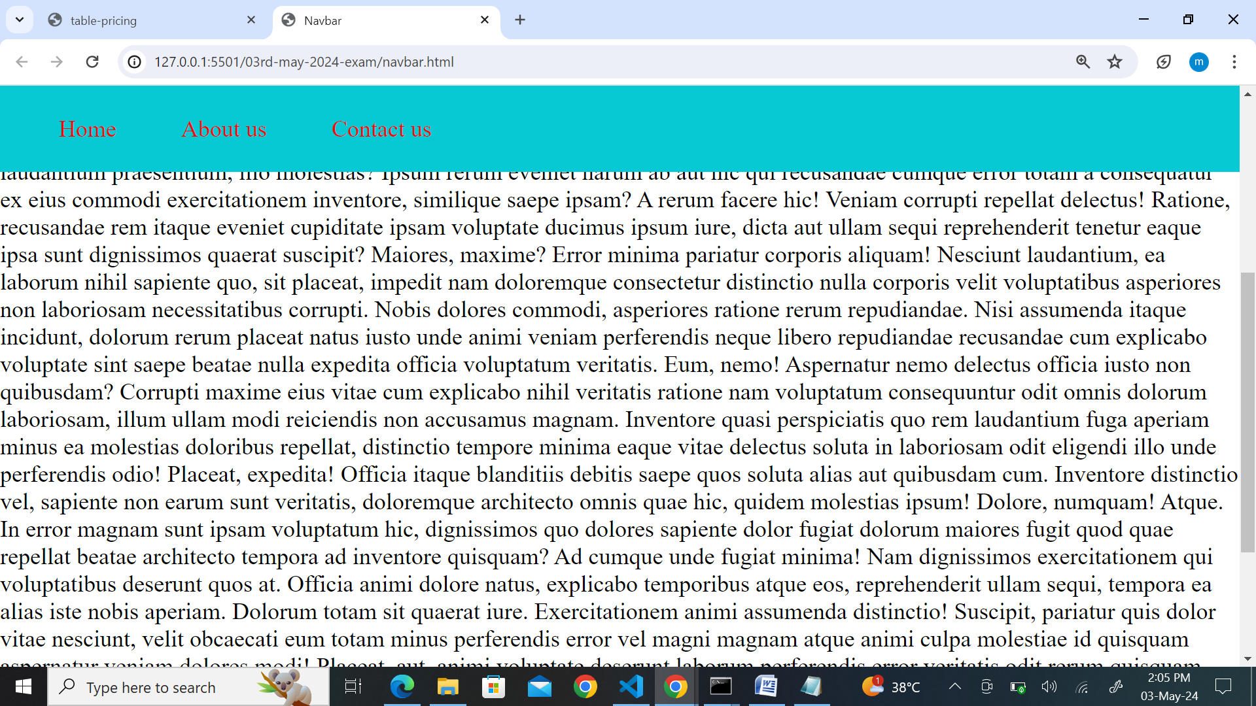

1. Implement a hover effect on images that enlarges them slightly.

Ans:

HTML File:

<!DOCTYPE html>

<html lang="en">

  <head>

    <meta charset="UTF-8" />

    <meta name="viewport" content="width=device-width, initial-scale=1.0" />

    <title>Image-transform</title>

    <link rel="stylesheet" href="image-transform.css" />

  </head>

  <body>

    <div>

      <img src="myself.JPG" alt="maicherla venkatesh" />

    </div>

  </body>

</html>

CSS File:

* {

  margin: 0px;

  padding: 0px;

  box-sizing: border-box;

}

div {

  display: flex;

  justify-content: center;

  align-items: center;

  height: 100vh;

}

div img {

  width: 150px;

  height: 250px;

  border: 3px solid rgb(173, 167, 169);

  border-radius: 25px;

  transition: transform 0.3s ease-in;

}

div img:hover {

  width: 250px;

  height: 350px;

}

Output:

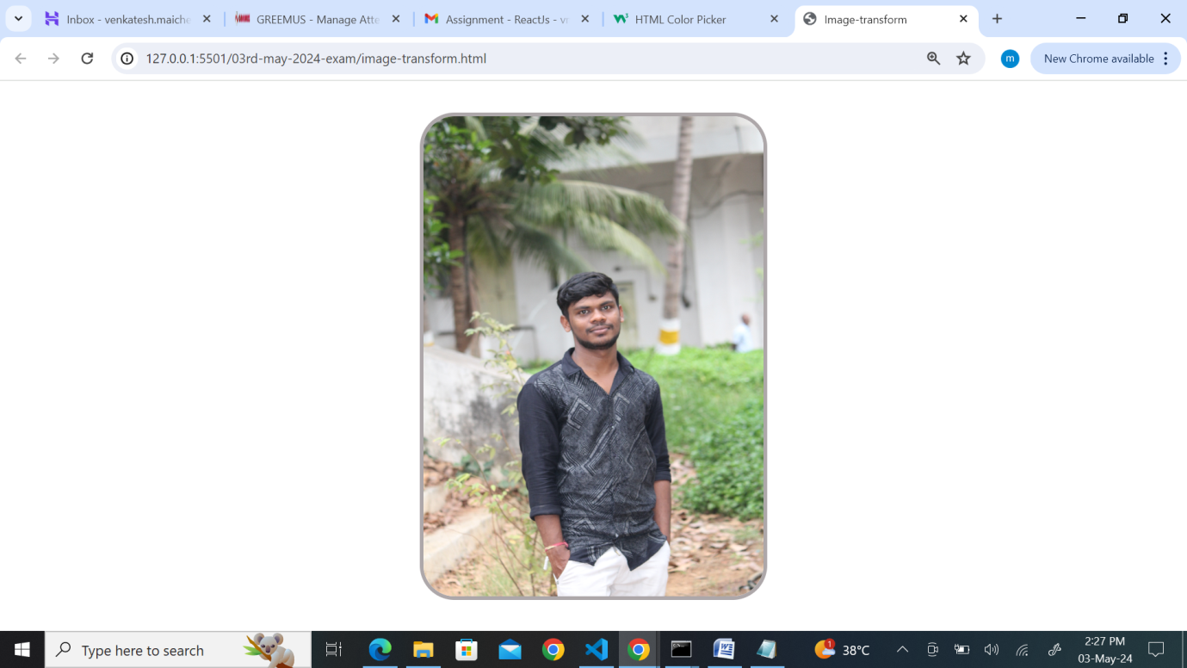

1. Create a login form with HTML and style it using CSS.

Ans:

HTML File:

<!DOCTYPE html>

<html lang="en">

  <head>

    <meta charset="UTF-8" />

    <meta name="viewport" content="width=device-width, initial-scale=1.0" />

    <title>login-form</title>

    <link rel="stylesheet" href="login-form.css" />

  </head>

  <body>

    <div class="form-container">

      <form>

        <h2>Login Form</h2>

        <div class="form-fields">

          <label for="username">username</label>

          <input

            type="text"

            placeholder="Enter the username here!"

            id="username"

            name="username"

          />

        </div>

        <div class="form-fields">

          <label for="pwd">password</label>

          <input

            type="password"

            placeholder="Enter the password here!"

            id="pwd"

            name="pwd"

          />

        </div>

        <button>login</button>

      </form>

    </div>

  </body>

</html>

CSS File:

* {

  margin: 0px;

  padding: 0px;

  box-sizing: border-box;

}

.form-container {

  display: flex;

  justify-content: center;

  align-items: center;

  height: 100vh;

}

.form-container form h2 {

  text-align: center;

  margin: 3px;

  font-size: 30px;

}

.form-container form {

  border: 2px solid rgb(167, 170, 174);

  border-radius: 5px;

  padding: 20px;

  background-color: lightpink;

  width: 50%;

}

.form-container form .form-fields input {

  width: 100%;

  padding: 6px;

  border: 2px solid rgb(61, 229, 220);

  border-radius: 6px;

  margin: 5px;

}

.form-container form button {

  width: 100%;

  padding: 6px;

  border: none;

  border-radius: 6px;

  margin: 5px;

  background-color: rgb(79, 170, 227);

  color: azure;

  font-size: 20px;

  cursor: pointer;

}

Output:

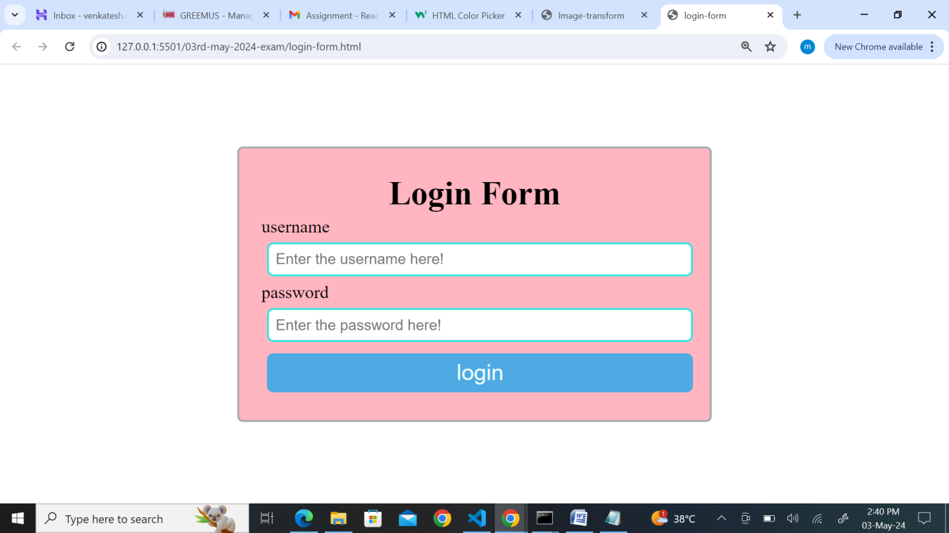

1. Build a responsive gallery that displays images in a grid format.

Ans:

HTML File:

<!DOCTYPE html>

<html lang="en">

  <head>

    <meta charset="UTF-8" />

    <meta name="viewport" content="width=device-width, initial-scale=1.0" />

    <title>grid display</title>

    <link rel="stylesheet" href="grid.css" />

  </head>

  <body>

    <div class="grid-container">

      <div>

        <h4>Image-1</h4>

        <img src="image-1.jpg" alt="image-1" />

      </div>

      <div>

        <h4>Image-2</h4>

        <img src="image-2.jpg" alt="image-2" />

      </div>

      <div>

        <h4>Image-3</h4>

        <img src="image-3.jpg " alt="image-3" />

      </div>

      <div>

        <h4>Image-4</h4>

        <img src="image-4.jpg" alt="image-4" />

      </div>

      <div>

        <h4>Image-5</h4>

        <img src="image-5.jpg" alt="image-5" />

      </div>

      <div>

        <h4>Image-6</h4>

        <img src="image-6.jpg" alt="image-6" />

      </div>

      <div>

        <h4>Image-7</h4>

        <img src="image-7.jpg" alt="image-7" />

      </div>

      <div>

        <h4>Image-8</h4>

        <img src="image-8.jpg" alt="image-8" />

      </div>

    </div>

  </body>

</html>

CSS File:

* {

  margin: 0px;

  padding: 0px;

  box-sizing: border-box;

}

.grid-container {

  display: grid;

  grid-template-columns: repeat(3, 1fr);

  grid-gap: 10px;

}

.grid-container div img {

  width: 200px;

  height: 200px;

  margin: 10px;

  border: 2px solid lightgreen;

  border-radius: 20px;

  box-shadow: 2px 2px 15px rgb(147, 114, 114);

}

.grid-container div h4 {

  text-align: center;

  font-size: 20px;

  font-family: "Segoe UI", Tahoma, Geneva, Verdana, sans-serif;

}

Output:

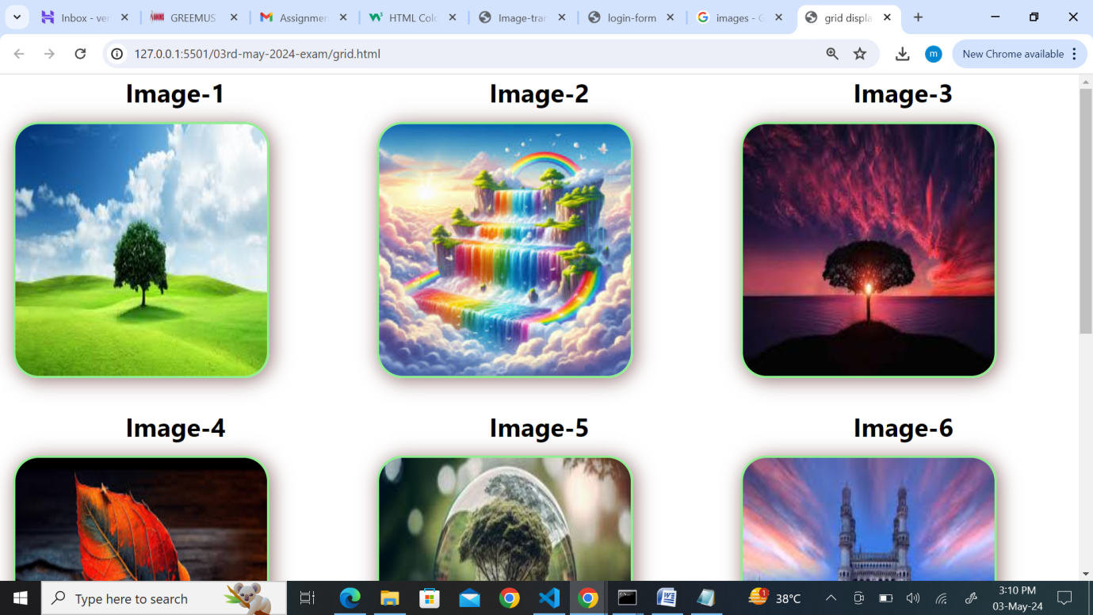

1. Style text to have different fonts, sizes, and colors on the same page.

Ans:

HTML File:

<!DOCTYPE html>

<html lang="en">

  <head>

    <meta charset="UTF-8" />

    <meta name="viewport" content="width=device-width, initial-scale=1.0" />

    <title>font-sizes,colors</title>

    <link rel="stylesheet" href="fonts-sizes.css" />

  </head>

  <body>

    <div class="font-container">

      <div class="total-fonts">

        <h1>My Self maicherla venkatesh</h1>

        <p class="from">From Anakapalle</p>

        <p class="works">works at greemus</p>

        <p class="eee">BTech(EEE)</p>

      </div>

    </div>

  </body>

</html>

CSS File:

* {

  margin: 0px;

  padding: 0px;

  box-sizing: border-box;

}

.font-container {

  display: flex;

  justify-content: center;

  align-items: center;

  height: 100vh;

}

.font-container .total-fonts h1 {

  font-family: "Gill Sans", "Gill Sans MT", Calibri, "Trebuchet MS", sans-serif;

  font-size: 30px;

  color: #04a18c;

  font-weight: bold;

}

.font-container .total-fonts .from {

  font-family: "Trebuchet MS", "Lucida Sans Unicode", "Lucida Grande",

    "Lucida Sans", Arial, sans-serif;

  font-size: 20px;

  color: rgb(210, 98, 98);

  font-variant: small-caps;

}

.font-container .total-fonts .works {

  font-family: "Segoe UI", Tahoma, Geneva, Verdana, sans-serif;

  font-weight: 600;

  color: rgb(209, 17, 17);

  font-size: 25px;

}

.font-container .total-fonts .eee {

  font-family: Georgia, "Times New Roman", Times, serif;

  font-weight: 800;

  color: rgb(203, 117, 13);

  font-size: 35px;

}

Output:

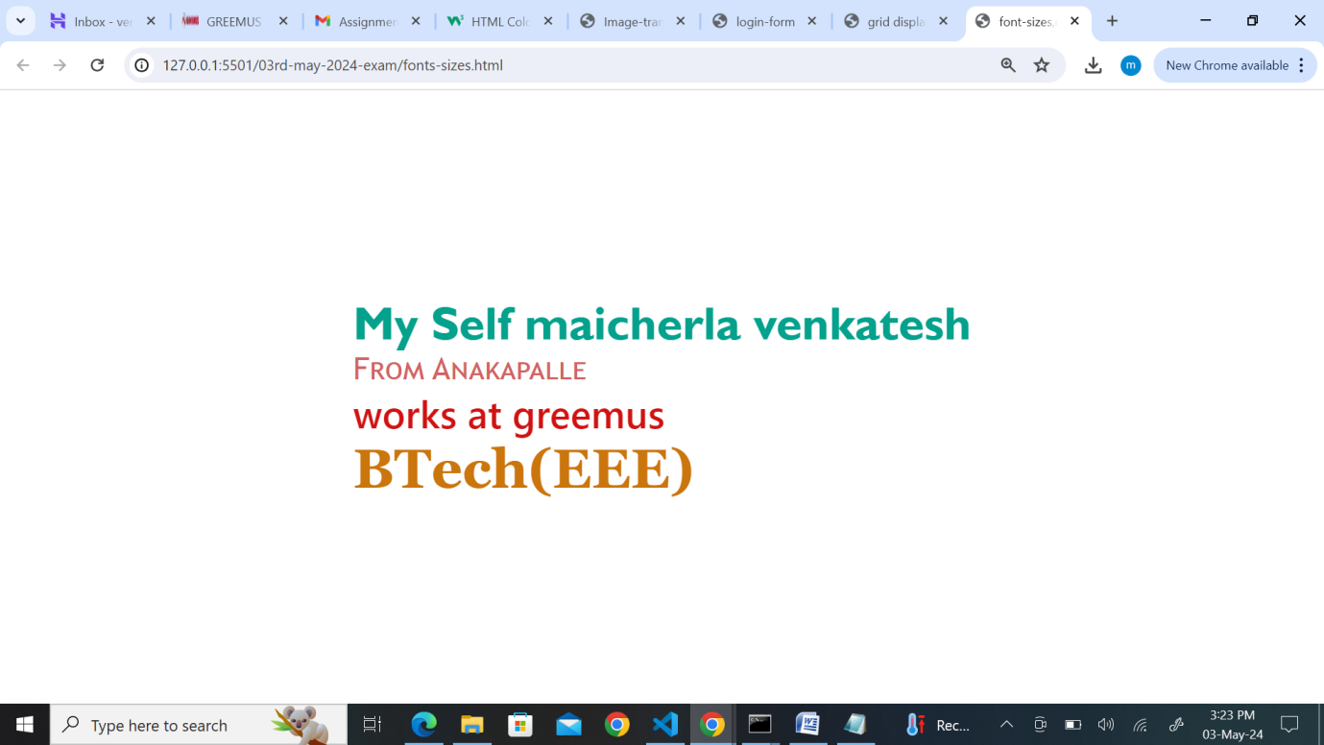

1. Design a footer that stays at the bottom of the page, regardless of content height.

Ans:

HTML File:

<!DOCTYPE html>

<html lang="en">

  <head>

    <meta charset="UTF-8" />

    <meta name="viewport" content="width=device-width, initial-scale=1.0" />

    <title>footer</title>

    <link rel="stylesheet" href="footer.css" />

  </head>

  <body>

    <div class="section-nav">

      <section>

        <nav>

          <a href="">Home</a>

          <a href="">About</a>

          <a href="">Contact</a>

        </nav>

        <div class="form-container">

          <form>

            <div class="form-fields">

              <label for="username">username</label>

              <input

                type="text"

                placeholder="Enter the username here!"

                id="username"

                name="username"

              />

            </div>

            <div class="form-fields">

              <label for="pwd">password</label>

              <input

                type="password"

                placeholder="Enter the password here!"

                id="pwd"

                name="pwd"

              />

            </div>

            <button>login</button>

          </form>

        </div>

      </section>

      <footer class="section-footer">

        <p>$ Written by venkatesh in 2024</p>

      </footer>

    </div>

  </body>

</html>

CSS File:

* {

  margin: 0px;

  padding: 0px;

  box-sizing: border-box;

}

.section-nav section nav {

  display: block;

  position: relative;

  background-color: rgb(206, 88, 227);

  padding: 20px;

  top: 0px;

}

.section-nav section nav a {

  text-decoration: none;

  margin: 20px;

  color: rgb(235, 241, 241);

}

.section-footer {

  position: absolute;

  width: 100%;

  line-height: 50px;

  height: 50px;

  background-color: #023637;

  color: #fff;

  text-align: center;

  bottom: 0;

}

.form-container {

  display: flex;

  justify-content: center;

  align-items: center;

  margin-top: 40px;

}

.form-container form h2 {

  text-align: center;

  margin: 3px;

  font-size: 30px;

}

.form-container form {

  border: 2px solid rgb(167, 170, 174);

  border-radius: 5px;

  padding: 20px;

  background-color: lightpink;

  width: 50%;

}

.form-container form .form-fields input {

  width: 100%;

  padding: 6px;

  border: 2px solid rgb(61, 229, 220);

  border-radius: 6px;

  margin: 5px;

}

.form-container form button {

  width: 100%;

  padding: 6px;

  border: none;

  border-radius: 6px;

  margin: 5px;

  background-color: rgb(79, 170, 227);

  color: azure;

  font-size: 20px;

  cursor: pointer;

}

Output:

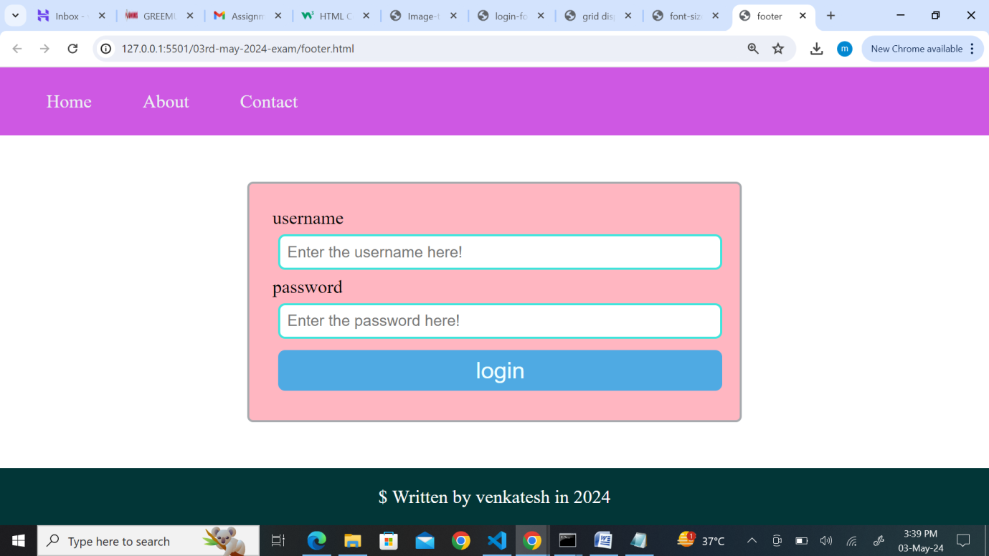

1. Make a horizontal scrolling website using CSS overflow property.

Ans:

HTML File:

<!DOCTYPE html>

<html lang="en">

  <head>

    <meta charset="UTF-8" />

    <meta name="viewport" content="width=device-width, initial-scale=1.0" />

    <title>horizontal scrol</title>

    <link rel="stylesheet" href="horizontal-scrol.css" />

  </head>

  <body>

    <div class="horizontal-container">

      <div class="horizontal-sections">

        <ol>

          <li>mumbai</li>

          <li>chenni</li>

          <li>dehli</li>

          <li>bangalore</li>

        </ol>

      </div>

      <div class="horizontal-sections">

        <ol>

          <li>rohit</li>

          <li>dhoni</li>

          <li>pant</li>

          <li>kohli</li>

        </ol>

      </div>

      <div class="horizontal-sections">

        <ul>

          <li>runs:560</li>

          <li>runs:670</li>

          <li>runs:789</li>

          <li>runs:340</li>

        </ul>

      </div>

    </div>

  </body>

</html>

CSS File:

* {

  margin: 0px;

  padding: 0px;

  box-sizing: border-box;

}

.horizontal-container {

  width: 100%;

  overflow-x: auto;

  white-space: nowrap;

  margin-top: 70px;

}

.horizontal-sections {

  display: inline-block;

  width: 100%;

  padding: 20px;

  background-color: #1d3336;

  box-sizing: border-box;

}

.horizontal-container ol {

  list-style-type: none;

}

.horizontal-container ol li {

  display: flex;

  justify-content: center;

  align-items: center;

  font-weight: bold;

  color: rgb(248, 252, 251);

}

.horizontal-container ul {

  list-style-type: none;

}

.horizontal-container ul li {

  display: flex;

  justify-content: center;

  align-items: center;

  font-weight: bold;

  color: rgb(218, 220, 219);

}

Output:

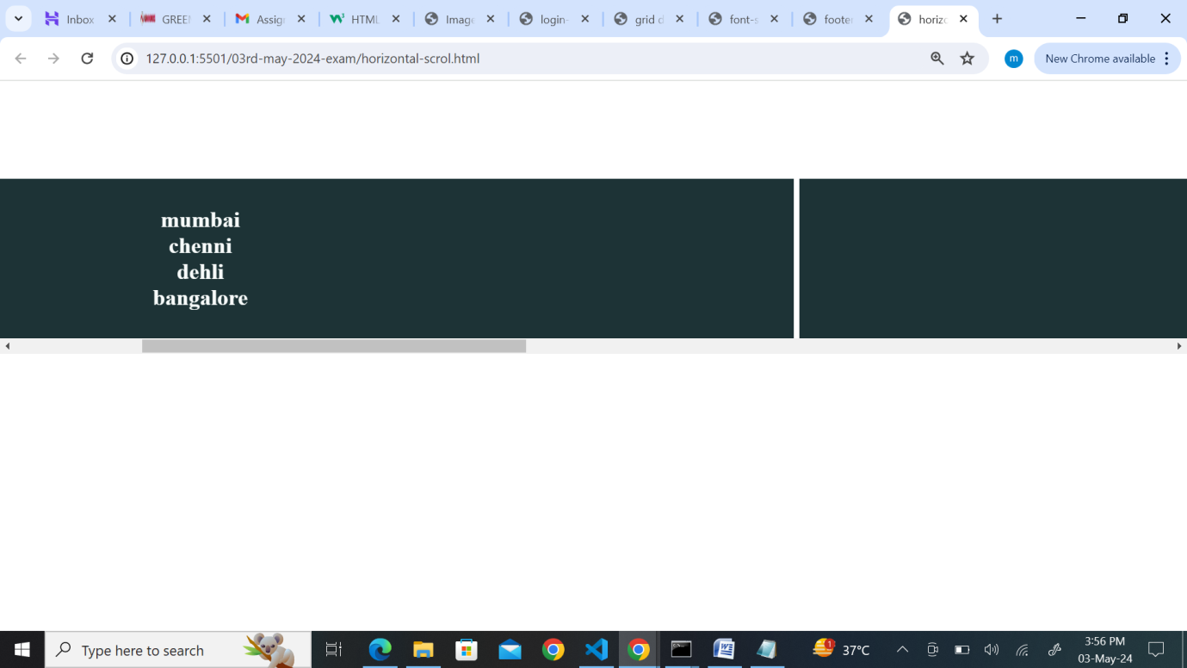

1. Create a progress bar using HTML and CSS.

Ans:

HTML File:

<!DOCTYPE html>

<html lang="en">

  <head>

    <meta charset="UTF-8" />

    <meta name="viewport" content="width=device-width, initial-scale=1.0" />

    <title>Prograss</title>

    <link rel="stylesheet" href="prograss.css" />

  </head>

  <body>

    <div class="skill">

      <div class="skill-item">

        <h5>HTML</h5>

        <progress id="file" value="95" max="100">95%</progress>

      </div>

      <div class="skill-item">

        <h5>CSS</h5>

        <progress id="file" value="80" max="100">80%</progress>

      </div>

    </div>

  </body>

</html>

CSS File;

* {

  margin: 0px;

  padding: 0px;

  box-sizing: border-box;

}

.skill {

  display: flex;

  justify-content: center;

  align-items: center;

  height: 100vh;

  gap: 30px;

  color: rgb(190, 3, 115);

}

progress {

  appearance: none;

  width: 150px;

  height: 20px;

}

progress::-webkit-progress-bar {

  background-color: #a16b6b;

  border-radius: 20px;

}

progress::-webkit-progress-value {

  background-color: #1fc0d5;

  border-radius: 20px;

}

Output;

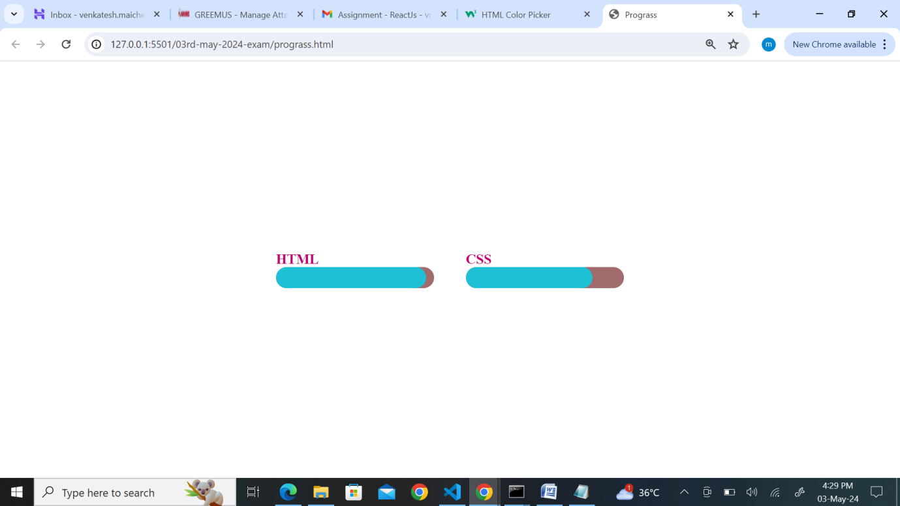

1. Implement a CSS animation on an element, such as a spinning effect.

Ans:

HTML File:

<!DOCTYPE html>

<html lang="en">

  <head>

    <meta charset="UTF-8" />

    <meta name="viewport" content="width=device-width, initial-scale=1.0" />

    <title>Spinner</title>

    <link rel="stylesheet" href="spinner.css" />

  </head>

  <body>

    <div class="spinner-container">

      <div class="content">

        <h4>maicherla venkatesh</h4>

      </div>

    </div>

  </body>

</html>

CSS File:

* {

  margin: 0px;

  padding: 0px;

  box-sizing: border-box;

}

.spinner-container {

  display: flex;

  justify-content: center;

  align-items: center;

  height: 100vh;

}

.spinner-container .content {

  background-color: rgb(205, 133, 144);

  width: 200px;

  height: 150px;

  border-radius: 40px;

  animation: spin 5s linear infinite;

}

.spinner-container .content h4 {

  text-align: center;

  margin-top: 70px;

  color: rgb(232, 229, 229);

}

@keyframes spin {

  from {

    transform: rotate(90deg);

  }

  to {

    transform: rotate(270deg);

  }

}

Output:

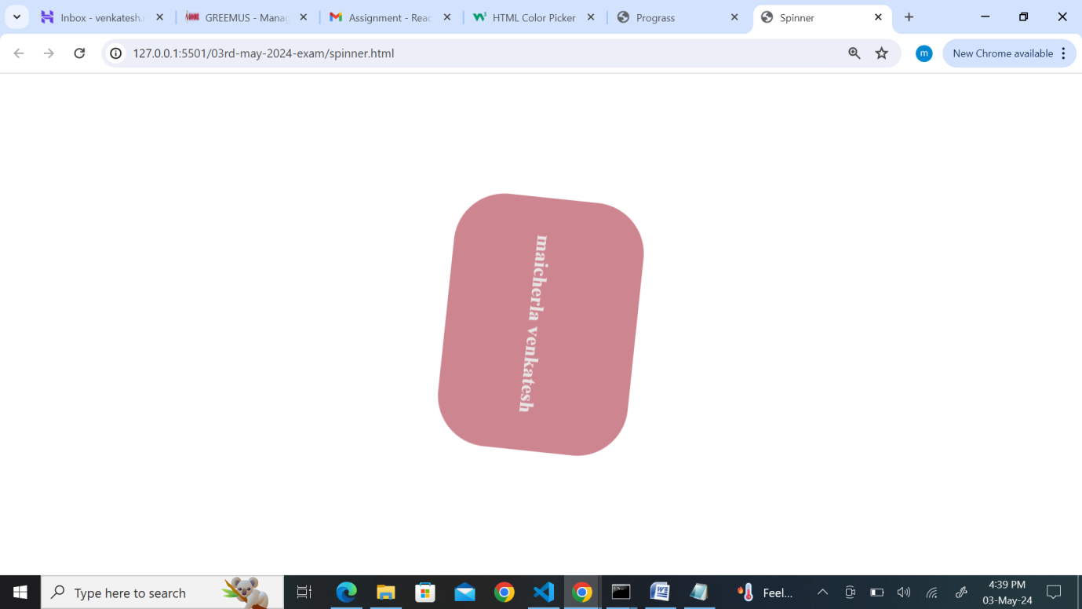

1. Build a tabbed content section using HTML, CSS, and JavaScript.

Ans:

1. Design a responsive carousel/slider for showcasing images.
2. Style a list to have custom bullet points and spacing between items.

Ans:

HTML File:

<!DOCTYPE html>

<html lang="en">

  <head>

    <meta charset="UTF-8" />

    <meta name="viewport" content="width=device-width, initial-scale=1.0" />

    <title>list</title>

    <link rel="stylesheet" href="list.css" />

  </head>

  <body>

    <div class="list-container">

      <h2>list items</h2>

      <ul>

        <li>HTML</li>

        <li>CSS</li>

        <li>Javascript</li>

        <li>React-js</li>

      </ul>

    </div>

  </body>

</html>

CSS File:

* {

  margin: 0px;

  padding: 0px;

  box-sizing: border-box;

}

.list-container {

  display: flex;

  justify-content: center;

  align-items: center;

  height: 100vh;

  flex-direction: column;

}

.list-container ul {

  list-style-type: none;

}

.list-container ul li::before {

  content: ".";

  font-size: 30px;

  color: rgb(190, 5, 42);

  position: absolute;

  top: 0;

  left: 0;

}

.list-container ul li {

  position: relative;

  padding-left: 25px;

  padding-top: 16px;

}

.list-container h2 {

  color: rgb(167, 87, 99);

  font-family: "Gill Sans", "Gill Sans MT", Calibri, "Trebuchet MS", sans-serif;

}

Output:

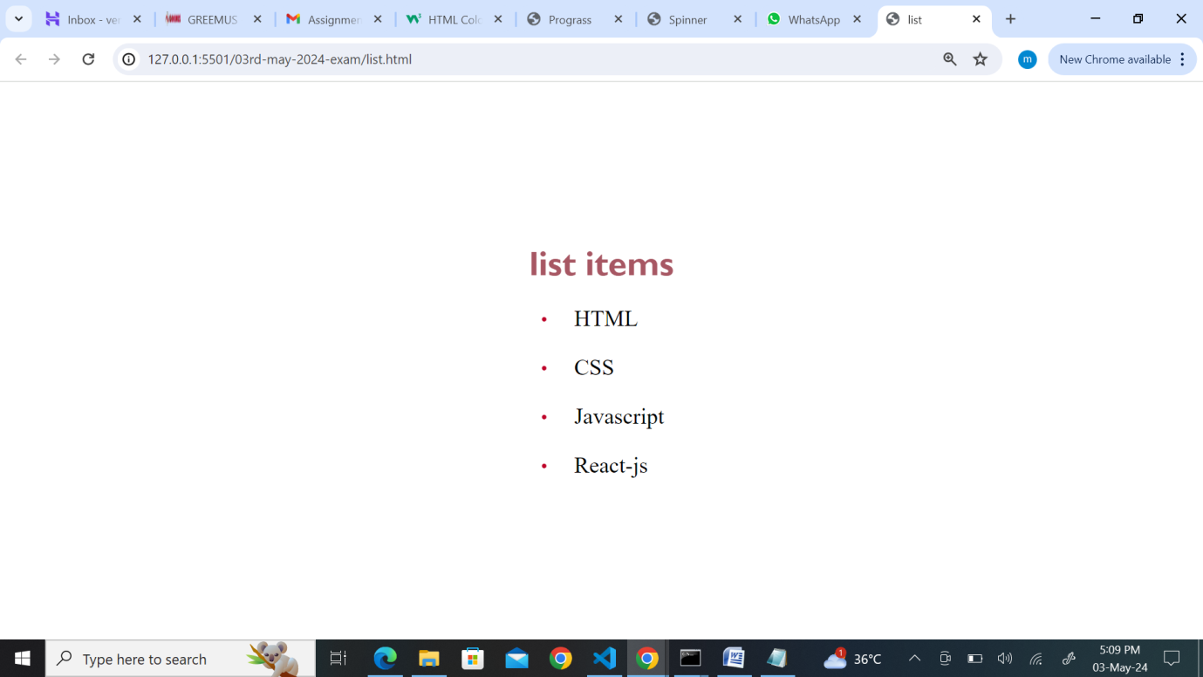

1. Make a website layout that uses a sticky sidebar.

Ans:

HTML File:

<!DOCTYPE html>

<html lang="en">

  <head>

    <meta charset="UTF-8" />

    <meta name="viewport" content="width=device-width, initial-scale=1.0" />

    <title>side-bar</title>

    <link rel="stylesheet" href="sidebar.css" />

  </head>

  <body>

    <div class="side-bar">

      <div class="side-items">

        <a href="">home</a>

        <a href="">about</a>

        <a href="">Contact</a>

      </div>

      <div class="main-content">

        <p>

          Lorem ipsum dolor sit amet consectetur adipisicing elit. Beatae at

          minus quae debitis inventore nostrum distinctio sed nihil quas et

          officiis autem reiciendis, velit iste sint, modi vel fugit?

          Aspernatur? Sit aperiam mollitia doloremque adipisci, corrupti officia

          voluptates alias aspernatur repellat quae animi dolor, quibusdam

          voluptatem sapiente. Impedit nemo, accusamus minima explicabo velit

          magnam nihil rerum ea et asperiores dolorum! Dolorem quasi nam

          corrupti ab, vel sit doloribus quia eveniet iure quas aliquid rerum

          placeat eius deserunt maiores aspernatur nihil et quis? Facere iste

          pariatur ullam magnam debitis obcaecati consequatur. Numquam veniam

          asperiores praesentium commodi autem non corrupti? Porro pariatur

          temporibus voluptatum dolores. Iure modi eum sint autem animi ratione

          voluptas laboriosam mollitia nostrum corporis aspernatur, veritatis

          aperiam deleniti delectus. Aspernatur assumenda blanditiis dolores id

          voluptates, illo suscipit dolorum explicabo iste est, perferendis nam

          corporis quasi sit, possimus nisi. Non cumque sed ratione reiciendis

          distinctio neque et illum eligendi ex? Voluptatum rerum autem sequi

          neque hic quasi repellendus incidunt ad nulla cum libero, reiciendis

          voluptates adipisci. Officia aut, ut quis quidem nobis ipsa, et, quod

          consectetur placeat doloribus dicta libero. Ducimus nihil perspiciatis

          porro neque necessitatibus aliquid a nam nostrum commodi, quasi

          explicabo corporis cupiditate! Sit atque, iure accusantium, nulla

          facilis maxime dolorum, dolor eligendi minus necessitatibus velit

          reiciendis labore? Et deleniti id dolor voluptas aperiam voluptatum.

          Quibusdam consequuntur laborum illo earum cum velit magni quaerat

          assumenda, nostrum ea, corrupti vel, incidunt aperiam eaque

          repellendus pariatur tenetur totam provident? Omnis. Veritatis eum

          ullam quia perspiciatis temporibus dolorum consequatur architecto

          voluptate adipisci blanditiis veniam, unde harum numquam expedita

          similique neque quidem voluptas excepturi. Totam itaque labore

          voluptas nostrum minima fugit ad! Reprehenderit animi facere ab

          adipisci aperiam nemo error quae voluptates maxime illum! Recusandae

          dolorum, quos vel dolor architecto corrupti ipsum alias minus eaque

          nisi ipsa pariatur, molestias quo facere quam. Lorem ipsum dolor sit

          amet consectetur adipisicing elit. Beatae at minus quae debitis

          inventore nostrum distinctio sed nihil quas et officiis autem

          reiciendis, velit iste sint, modi vel fugit? Aspernatur? Sit aperiam

          mollitia doloremque adipisci, corrupti officia voluptates alias

          aspernatur repellat quae animi dolor, quibusdam voluptatem sapiente.

          Impedit nemo, accusamus minima explicabo velit magnam nihil rerum ea

          et asperiores dolorum! Dolorem quasi nam corrupti ab, vel sit

          doloribus quia eveniet iure quas aliquid rerum placeat eius deserunt

          maiores aspernatur nihil et quis? Facere iste pariatur ullam magnam

          debitis obcaecati consequatur. Numquam veniam asperiores praesentium

          commodi autem non corrupti? Porro pariatur temporibus voluptatum

          dolores. Iure modi eum sint autem animi ratione voluptas laboriosam

          mollitia nostrum corporis aspernatur, veritatis aperiam deleniti

          delectus. Aspernatur assumenda blanditiis dolores id voluptates, illo

          suscipit dolorum explicabo iste est, perferendis nam corporis quasi

          sit, possimus nisi. Non cumque sed ratione reiciendis distinctio neque

          et illum eligendi ex? Voluptatum rerum autem sequi neque hic quasi

          repellendus incidunt ad nulla cum libero, reiciendis

        </p>

      </div>

    </div>

  </body>

</html>

CSS File:

* {

  margin: 0px;

  padding: 0px;

  box-sizing: border-box;

}

.side-bar {

  display: flex;

}

.side-bar .side-items {

  flex: 0 0 20%;

  padding: 20px;

  position: sticky;

  top: 0;

  background-color: lightpink;

  height: 100vh;

  overflow: hidden;

}

.side-bar .main-content {

  flex: 0 0 80%;

}

.side-bar .side-items a {

  text-decoration: none;

  display: flex;

  flex-direction: column;

  position: relative;

  left: 50px;

  top: 70px;

  padding-top: 40px;

}

.side-bar .main-content {

  background-color: lightseagreen;

  padding-left: 20px;

}

Output:

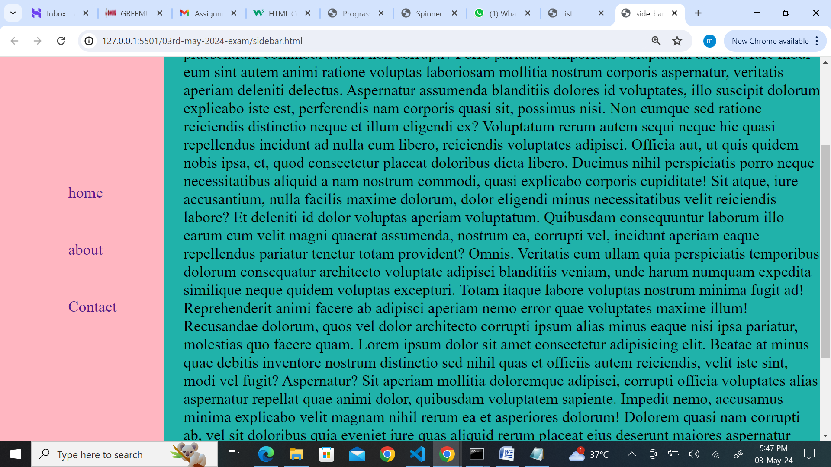

1. Create a simple tooltip using HTML and CSS.

Ans:

1. Design a card layout for displaying content with an image, title, and description.

Ans:

HTML File:

<!DOCTYPE html>

<html lang="en">

  <head>

    <meta charset="UTF-8" />

    <meta name="viewport" content="width=device-width, initial-scale=1.0" />

    <title>cards</title>

    <link rel="stylesheet" href="cards.css" />

  </head>

  <body>

    <div class="card-container">

      <div class="Individual-cards">

        <img src="image-1.jpg" alt="Image" />

        <div class="about-area">

          <h3 class="title-area">this is title area</h3>

          <p class="about-card">this is a description area</p>

        </div>

      </div>

      <div class="Individual-cards">

        <img src="image-2.jpg" alt="Image" />

        <div class="about-area">

          <h3 class="title-area">this is title area</h3>

          <p class="about-card">this is title area</p>

        </div>

      </div>

      <div class="Individual-cards">

        <img src="image-3.jpg" alt="Image" />

        <div class="about-area">

          <h3 class="title-area">this is title area</h3>

          <p class="about-card">this is title area</p>

        </div>

      </div>

      <div class="Individual-cards">

        <img src="image-4.jpg" alt="Image" />

        <div class="about-area">

          <h3 class="title-area">this is title area</h3>

          <p class="about-card">this is title area</p>

        </div>

      </div>

      <div class="Individual-cards">

        <img src="image-5.jpg" alt="Image" />

        <div class="about-area">

          <h3 class="title-area">this is title area</h3>

          <p class="about-card">this is title area</p>

        </div>

      </div>

      <div class="Individual-cards">

        <img src="image-6.jpg" alt="Image" />

        <div class="about-area">

          <h3 class="title-area">this is title area</h3>

          <p class="about-card">this is title area</p>

        </div>

      </div>

      <div class="Individual-cards">

        <img src="image-7.jpg" alt="Image" />

        <div class="about-area">

          <h3 class="title-area">this is title area</h3>

          <p class="about-card">this is title area</p>

        </div>

      </div>

      <div class="Individual-cards">

        <img src="image-8.jpg" alt="Image" />

        <div class="about-area">

          <h3 class="title-area">this is title area</h3>

          <p class="about-card">this is title area</p>

        </div>

      </div>

    </div>

  </body>

</html>

CSS File:

* {

  margin: 0px;

  padding: 0px;

  box-sizing: border-box;

}

.card-container {

  display: grid;

  grid-template-columns: repeat(3, 1fr);

  grid-gap: 20px;

  justify-content: center;

  padding: 20px;

}

.Individual-cards {

  border-radius: 10px;

  box-shadow: 0 4px 8px rgba(0, 0, 0, 0.1);

  overflow: hidden;

  transition: transform 0.3s;

}

.Individual-cards img {

  width: 100%;

  height: 200px;

  object-fit: cover;

}

.about-area {

  padding: 20px;

}

.title-area {

  font-size: 20px;

  font-weight: 300;

  margin-bottom: 8px;

}

.about-card {

  color: #724343;

  font-size: 24px;

}

.Individual-cards:hover {

  transform: translateY(-10px);

}

Output:

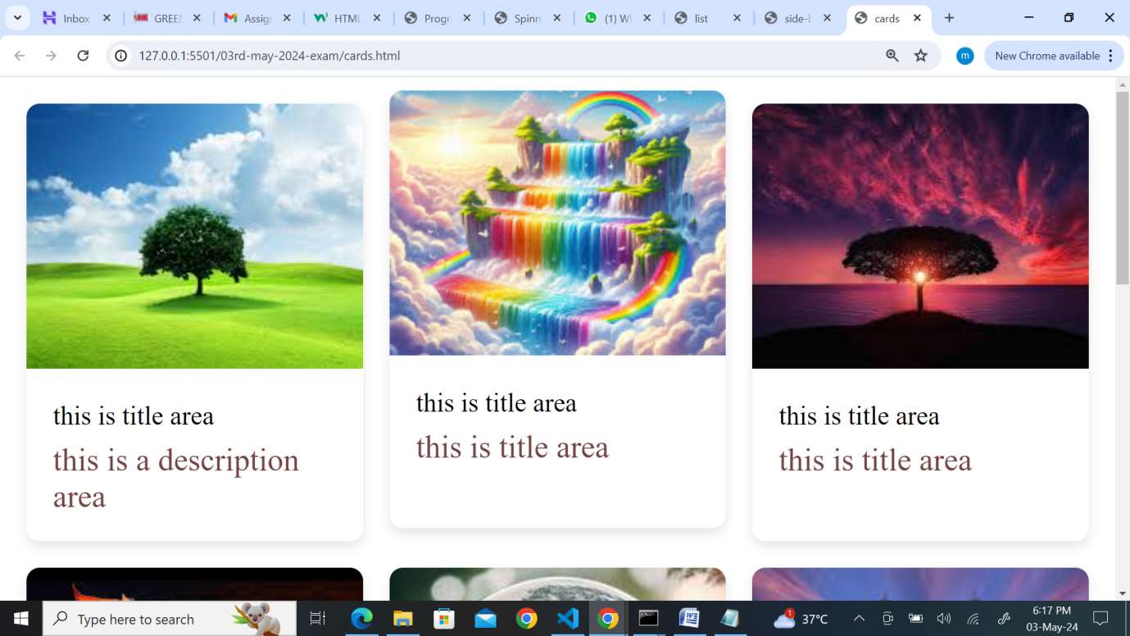

1. Implement a CSS transition on a button to change color smoothly.

Ans:

HTML File:

<!DOCTYPE html>

<html lang="en">

  <head>

    <meta charset="UTF-8" />

    <meta name="viewport" content="width=device-width, initial-scale=1.0" />

    <title>button-hover</title>

    <link rel="stylesheet" href="button-hover.css" />

  </head>

  <body>

    <div class="form-container">

      <form class="form-fields">

        <div class="name-field">

          <label for="name">name</label>

          <input

            type="text"

            id="name"

            name="name"

            placeholder="Enter the name here!"

          />

        </div>

        <input class="button" type="submit" value="submit" />

      </form>

    </div>

  </body>

</html>

CSS File:

* {

  margin: 0px;

  padding: 0px;

  box-sizing: border-box;

}

.form-container {

  display: flex;

  justify-content: center;

  align-items: center;

  height: 100vh;

}

.form-fields {

  border: 2px solid rgb(136, 8, 27);

  background-color: lightpink;

  padding: 20px;

  width: 50%;

}

.name-field input {

  width: 100%;

  padding: 6px;

}

.button {

  width: 100%;

  padding: 6px;

  background-color: rgb(4, 97, 155);

  border: none;

  color: black;

  margin-top: 10px;

}

.button:hover {

  background-color: rgb(5, 193, 190);

  color: #ffff;

}

Output:

Without hover:

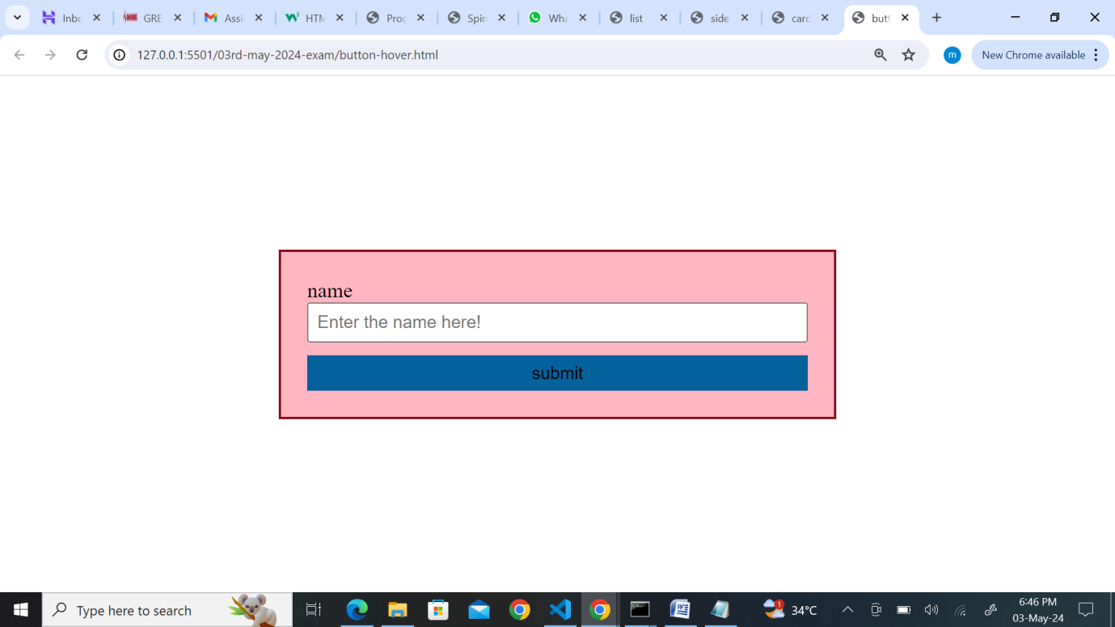

With hover:

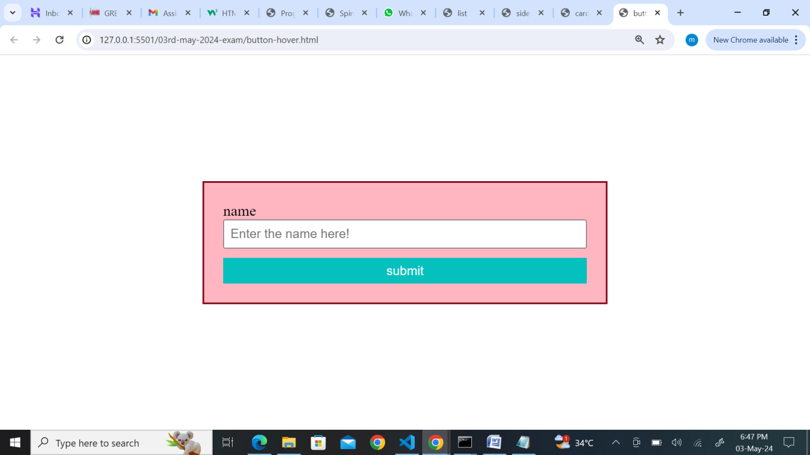

1. Build a responsive navbar with a hamburger menu for mobile devices.

Ans:

HTML File:

<!DOCTYPE html>

<html lang="en">

  <head>

    <meta charset="UTF-8" />

    <meta name="viewport" content="width=device-width, initial-scale=1.0" />

    <title>responsive-nav</title>

    <link rel="stylesheet" href="res-nav.css" />

    <link

      rel="stylesheet"

      href="https://cdnjs.cloudflare.com/ajax/libs/font-awesome/6.5.2/css/all.min.css"

      integrity="sha512-SnH5WK+bZxgPHs44uWIX+LLJAJ9/2PkPKZ5QiAj6Ta86w+fsb2TkcmfRyVX3pBnMFcV7oQPJkl9QevSCWr3W6A=="

      crossorigin="anonymous"

      referrerpolicy="no-referrer"

    />

  </head>

  <body>

    <div class="nav-conatiner">

      <section>

        <nav>

          <a href="">Home</a>

          <a href="">About us</a>

          <a href="">Contact us</a>

          <i class="fa fa-bars"></i>

        </nav>

        <div>

          <h2>maicherla venkatesh</h2>

          <p>

            Lorem ipsum dolor sit amet consectetur adipisicing elit. Suscipit

            eum, incidunt cupiditate consequatur magni dolorum dignissimos quod

            ab, molestias distinctio consequuntur. Tempora necessitatibus

            consequatur at? Accusamus amet modi sapiente illum! Incidunt ab

            autem quo perspiciatis earum numquam modi eos in ipsam possimus

            culpa, repellendus tempore adipisci omnis commodi laboriosam?

            Mollitia minus nemo ullam possimus quisquam voluptates numquam

            doloribus suscipit veritatis? Libero vero eaque quae consequuntur

            totam inventore aut voluptatibus? Pariatur inventore accusamus,

            saepe deleniti, atque sunt laborum expedita asperiores fugiat

            suscipit ratione distinctio, eum et eos nihil enim dolorum repellat!

            Delectus quod placeat corrupti, natus earum hic recusandae rerum

            consequatur cum. Reiciendis, eos. Voluptatibus, placeat vitae

            aliquid molestias culpa quas iure libero esse necessitatibus unde

            voluptatum voluptates, temporibus, numquam facere! Ipsam excepturi,

            odit placeat blanditiis aliquam, illum doloribus molestiae,

            molestias magni corporis nobis dolores rem quia odio! Nisi

            recusandae velit soluta qui nihil quod, amet omnis adipisci

            blanditiis veritatis id. Vero recusandae delectus sunt

            exercitationem unde labore tempore quibusdam, consequuntur

            molestiae, repudiandae earum iure, reiciendis quo. Ad quidem, quasi

            necessitatibus distinctio quo perspiciatis id molestiae, ipsam

            laudantium praesentium, illo molestias? Ipsum rerum eveniet harum ab

            aut hic qui recusandae cumque error totam a consequatur ex eius

            commodi exercitationem inventore, similique saepe ipsam? A rerum

            facere hic! Veniam corrupti repellat delectus! Ratione, recusandae

            rem itaque eveniet cupiditate ipsam voluptate ducimus ipsum iure,

            dicta aut ullam sequi reprehenderit tenetur eaque ipsa sunt

            dignissimos quaerat suscipit? Maiores, maxime? Error minima pariatur

            corporis aliquam! Nesciunt laudantium, ea laborum nihil sapiente

            quo, sit placeat, impedit nam doloremque consectetur distinctio

            nulla corporis velit voluptatibus asperiores non laboriosam

            necessitatibus corrupti. Nobis dolores commodi, asperiores ratione

            rerum repudiandae. Nisi assumenda itaque incidunt, dolorum rerum

            placeat natus iusto unde animi veniam perferendis neque libero

            repudiandae recusandae cum explicabo voluptate sint saepe beatae

            nulla expedita officia voluptatum veritatis. Eum, nemo! Aspernatur

            nemo delectus officia iusto non quibusdam? Corrupti maxime eius

            vitae cum explicabo nihil veritatis ratione nam voluptatum

            consequuntur odit omnis dolorum laboriosam, illum ullam modi

            reiciendis non accusamus magnam. Inventore quasi perspiciatis quo

            rem laudantium fuga aperiam minus ea molestias doloribus repellat,

            distinctio tempore minima eaque vitae delectus soluta in laboriosam

            odit eligendi illo unde perferendis odio! Placeat, expedita! Officia

            itaque blanditiis debitis saepe quos soluta alias aut quibusdam cum.

            Inventore distinctio vel, sapiente non earum sunt veritatis,

            doloremque architecto omnis quae hic, quidem molestias ipsum!

            Dolore, numquam! Atque. In error magnam sunt ipsam voluptatum hic,

            dignissimos quo dolores sapiente dolor fugiat dolorum maiores fugit

            quod quae repellat beatae architecto tempora ad inventore quisquam?

            Ad cumque unde fugiat minima! Nam dignissimos exercitationem qui

            voluptatibus deserunt quos at. Officia animi dolore natus, explicabo

            temporibus atque eos, reprehenderit ullam sequi, tempora ea alias

            iste nobis aperiam. Dolorum totam sit quaerat iure. Exercitationem

            animi assumenda distinctio! Suscipit, pariatur quis dolor vitae

            nesciunt, velit obcaecati eum totam minus perferendis error vel

            magni magnam atque animi culpa molestiae id quisquam aspernatur

            veniam dolores modi! Placeat, aut, animi voluptate deserunt laborum

            perferendis error veritatis odit rerum quisquam officiis distinctio?

            Mollitia eum facilis nobis laboriosam non, pariatur ipsam

            consectetur labore assumenda dolorem! Itaque explicabo asperiores

            suscipit? Architecto iste cupiditate ipsa commodi sed eligendi ab.

            Facilis eius eligendi est dicta sint porro fuga, nulla, ad, dolor

            harum aspernatur earum delectus dolores rem cum quae error veniam

            laborum! Repudiandae labore delectus illo culpa nam unde blanditiis

            harum esse possimus assumenda dolore officia error sunt molestiae

            fugit provident iure voluptatum aperiam natus dolores ipsam,

            suscipit totam quisquam! Maiores, pariatur? Commodi, tempore

            consequatur. Consequatur culpa, quo iste maiores eius adipisci

            doloribus, enim autem nulla laboriosam dolorem sint atque saepe?

            Nostrum aperiam exercitationem obcaecati expedita nam velit neque

            aut cumque earum?

          </p>

        </div>

      </section>

    </div>

  </body>

</html>

CSS File:

* {

  margin: 0px;

  padding: 0px;

  box-sizing: border-box;

}

.nav-conatiner section nav {

  display: block;

  position: sticky;

  overflow: hidden;

  background-color: rgb(189, 33, 186);

  padding: 20px;

  top: 0px;

}

.nav-conatiner section nav a {

  text-decoration: none;

  margin: 20px;

  color: rgb(252, 249, 249);

}

.nav-conatiner section nav i {

  color: rgb(249, 246, 246);

}

@media screen and (max-width: 789px) {

  .nav-container section nav {

    flex-direction: column;

    align-items: flex-start;

    justify-content: flex-start;

    background-color: lightpink;

    color: #ffff;

  }

  .nav-container section nav a {

    margin: 10px 20px;

  }

}

Output:

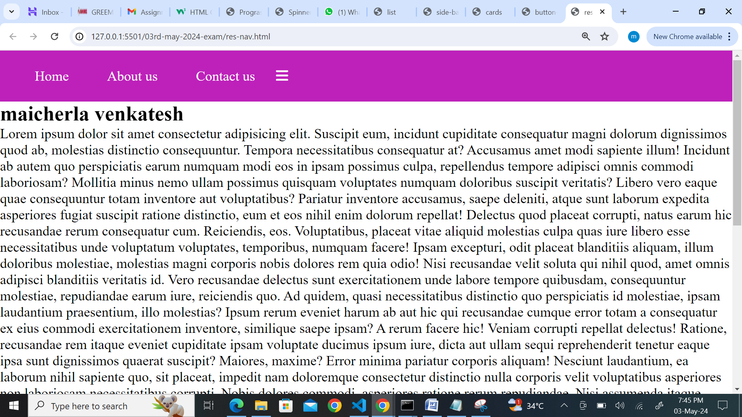

1. Style a table to have alternating row colors and a hover effect on rows.

Ans:

HTML File:

<!DOCTYPE html>

<html lang="en">

  <head>

    <meta charset="UTF-8" />

    <meta name="viewport" content="width=device-width, initial-scale=1.0" />

    <title>table</title>

    <link rel="stylesheet" href="table.css" />

  </head>

  <body>

    <div class="table-container">

      <table>

        <tr>

          <th>name</th>

          <th>qualification</th>

          <th>percentage</th>

        </tr>

        <tr>

          <td>venkatesh</td>

          <td>BTech</td>

          <td>72%</td>

        </tr>

        <tr>

          <td>Raju</td>

          <td>Degree</td>

          <td>67%</td>

        </tr>

        <tr>

          <td>Srinu</td>

          <td>BTech</td>

          <td>68%</td>

        </tr>

      </table>

    </div>

  </body>

</html>

CSS File:

* {

  margin: 0px;

  padding: 0px;

  box-sizing: border-box;

}

.table-container {

  display: flex;

  justify-content: center;

  align-items: center;

  height: 100vh;

}

table,

th,

td {

  border: 2px solid lightpink;

  border-collapse: collapse;

  padding: 20px;

}

table tr:nth-child(even) {

  background-color: rgb(2, 186, 146);

  color: rgb(241, 244, 243);

}

Output:

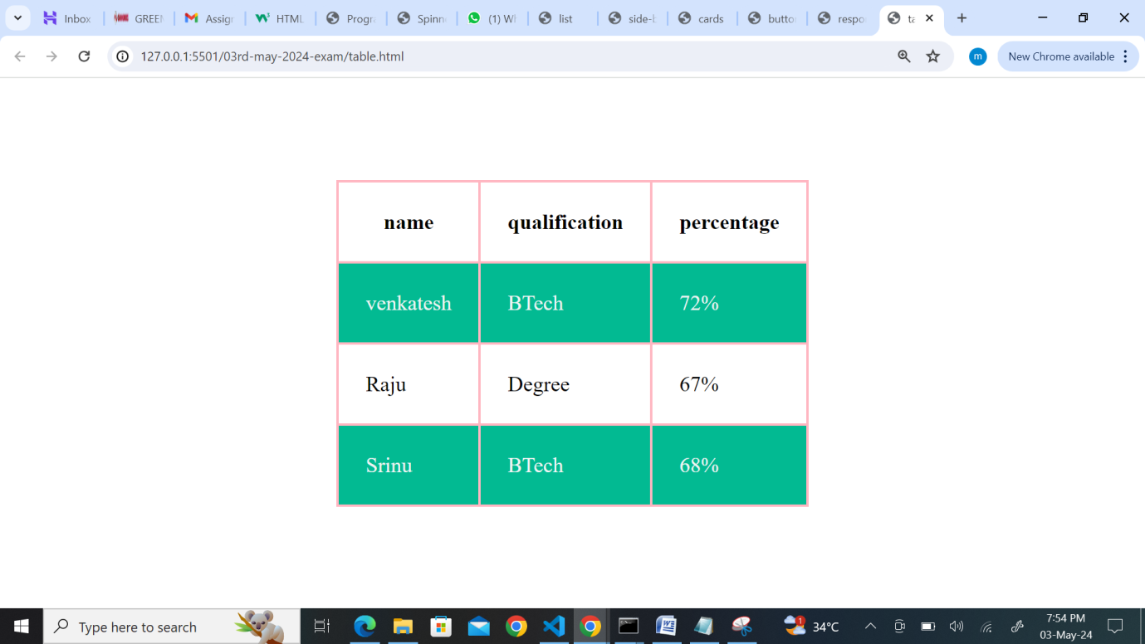

1. Design a progress tracker with steps using HTML and CSS.

Ans:

HTML File:

<!DOCTYPE html>

<html lang="en">

  <head>

    <meta charset="UTF-8" />

    <meta name="viewport" content="width=device-width, initial-scale=1.0" />

    <title>prograss</title>

    <link rel="stylesheet" href="progress-tracker.css" />

  </head>

  <body>

    <div class="tracker">

      <div class="steps active">

        <span>step1</span>

      </div>

      <div class="steps">

        <span>step2</span>

      </div>

      <div class="steps">

        <span>step3</span>

      </div>

    </div>

  </body>

</html>

CSS File:

* {

  margin: 0px;

  padding: 0px;

  box-sizing: border-box;

}

.tracker {

  display: flex;

  justify-content: center;

  align-items: center;

  height: 100vh;

}

.tracker .steps span {

  padding: 20px 40px;

  margin: 10px;

  background-color: rgb(246, 247, 248);

  border: 2px solid rgb(224, 212, 213);

  box-shadow: 4px 4px 10px rgb(57, 56, 56);

  border-radius: 10px;

  color: rgb(7, 108, 122);

}

.tracker .steps.active span {

  background-color: lightpink;

  color: rgb(45, 44, 44);

}

Output:

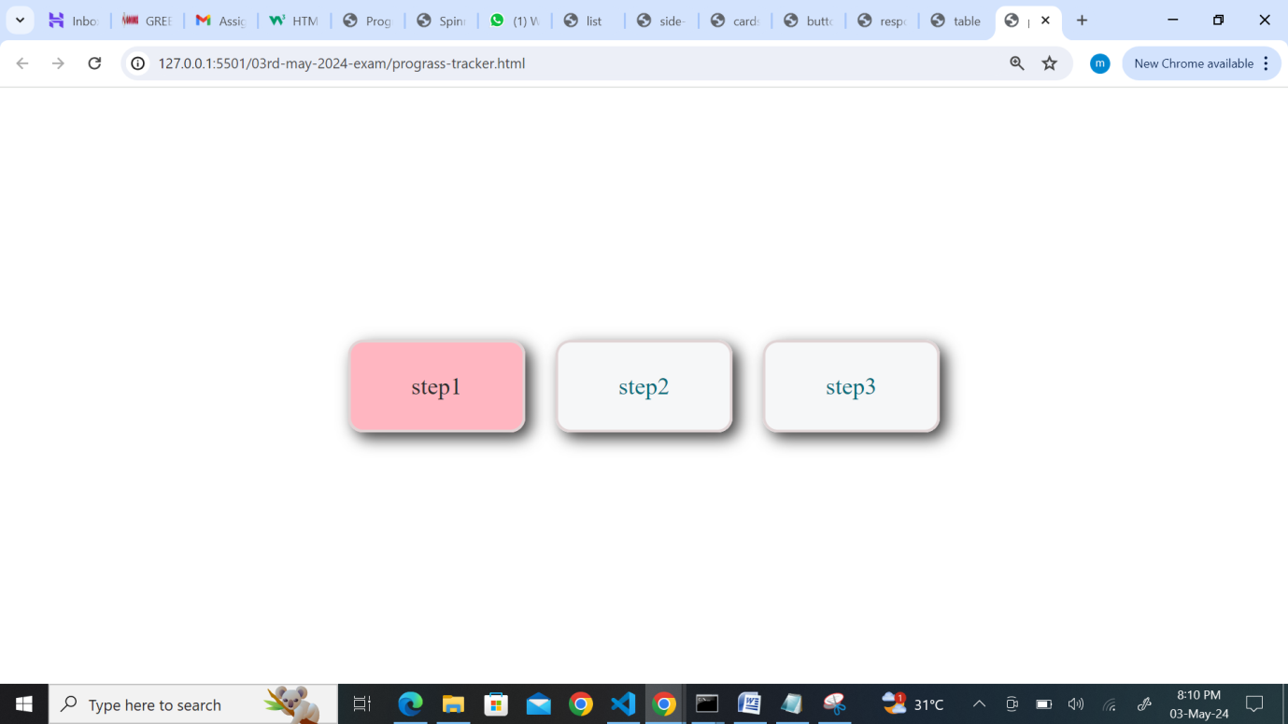

1. Create a parallax scrolling effect on a webpage background.

Ans:

HTML File:

<!DOCTYPE html>

<html lang="en">

  <head>

    <meta charset="UTF-8" />

    <meta name="viewport" content="width=device-width, initial-scale=1.0" />

    <title>Parallax scroll</title>

    <link rel="stylesheet" href="parallax.css" />

  </head>

  <body>

    <div class="parallax-container">

      <h2>Parallax scrol</h2>

      <div class="background-parallax"></div>

      <div class="parallax-content">

        <h1>Maicherla venkatesh</h1>

        <p>I am from visakhapatnam</p>

      </div>

    </div>

  </body>

</html>

CSS File:

* {

  margin: 0px;

  padding: 0px;

  box-sizing: border-box;

}

.background-parallax {

  background-image: url("myself.JPG");

  background-size: cover;

  background-attachment: fixed;

  height: 100%;

}

.parallax-content {

  height: 1000px;

  background-color: rgba(205, 137, 137, 0.8);

  padding: 20px;

}

.parallax-container {

  display: inline-block;

  justify-content: center;

  align-items: center;

  height: 100vh;

}

Output:

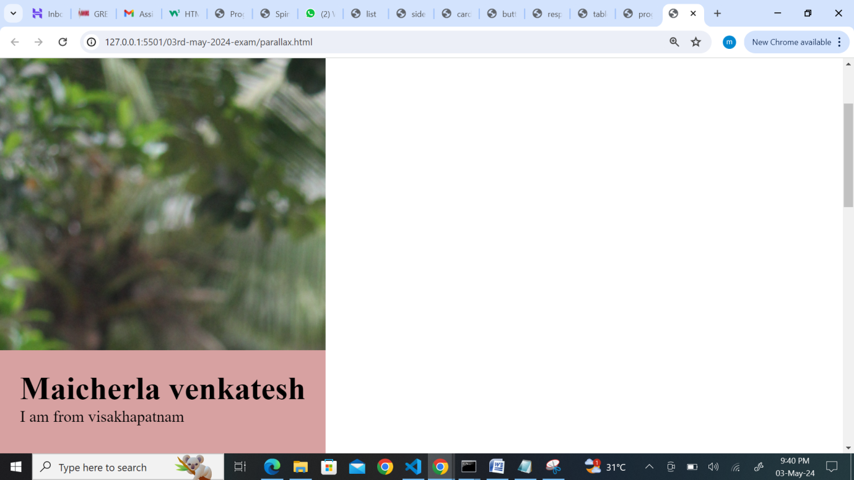

1. Build a dropdown select menu with options styled using CSS

Ans:

HTML File:

<!DOCTYPE html>

<html lang="en">

  <head>

    <meta charset="UTF-8" />

    <meta name="viewport" content="width=device-width, initial-scale=1.0" />

    <title>dropdown-menu</title>

    <link rel="stylesheet" href="dropdown.css" />

  </head>

  <body>

    <div class="dropdown-list">

      <select>

        <option>select names from the list</option>

        <option>Rohit</option>

        <option>jaiswal</option>

        <option>kohli</option>

        <option>surya</option>

        <option>pant</option>

        <option>jadeja</option>

        <option>hardik</option>

        <option>bumrah</option>

        <option>siraj</option>

        <option>kuldeep</option>

        <option>arshadeep</option>

      </select>

    </div>

  </body>

</html>

CSS File:

* {

  margin: 0px;

  padding: 0px;

  box-sizing: border-box;

}

.dropdown-list {

  display: flex;

  justify-content: center;

  align-items: center;

  height: 100vh;

}

.dropdown-list select {

  border: 3px solid lightseagreen;

  padding: 10px;

  width: 50%;

  border-radius: 20px;

  -webkit-appearance: none;

}

.dropdown-list select option {

  font-size: 15px;

  font-family: "Lucida Sans", "Lucida Sans Regular", "Lucida Grande",

    "Lucida Sans Unicode", Geneva, Verdana, sans-serif;

}

Output:

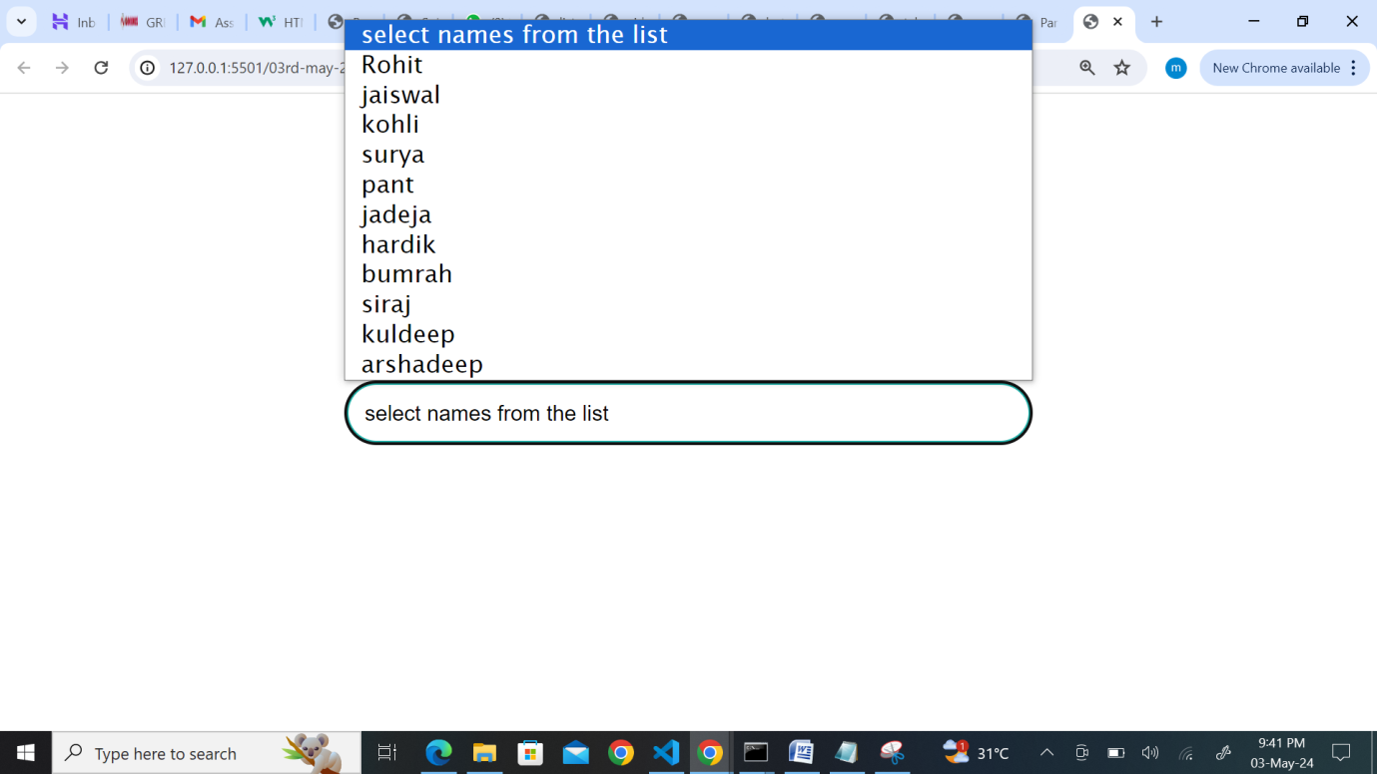

**mini projects:atleast need to complete 4 projects by monday**

1. Portfolio Website: Create a personal portfolio website showcasing your skills, projects, and contact information. Include sections for about me, projects, skills, and contact.
2. E-commerce Product Page: Design a product page for an online store. Include product images, description, price, and add-to-cart functionality.
3. Travel Blog: Build a travel blog website with articles, images, and categories for different destinations. Use CSS to style the layout and make it visually appealing.
4. Restaurant Website: Design a website for a restaurant with a menu, photo gallery, location/map, and contact form for reservations.
5. Event Landing Page: Create a landing page for an upcoming event or conference. Include event details, schedule, speakers, and registration form.
6. Online Resume/CV: Build an online resume or CV with sections for education, work experience, skills, and contact information. Use CSS to make it visually appealing and easy to read.
7. Weather App Interface: Design a simple weather app interface showing current weather conditions, temperature, and forecast for the week.
8. Fitness Tracker Dashboard: Create a dashboard for tracking fitness goals, workouts, and progress. Include charts/graphs to visualize data.
9. Music Player Interface: Design a music player interface with play/pause buttons, volume control, and playlist display.
10. Recipe Blog: Build a recipe blog website with recipes, ingredients, instructions, and cooking tips. Use CSS to style the layout and make it visually appealing.
11. Job Board: Create a job board website where employers can post job listings and job seekers can search and apply for jobs.